MECSOL 2022 - Template for Paper Publication in Proceedings (Helvetica 16pt)

First Author 1, Second Author 2, and Third Author 1 (Helvetica 9pt Bold)

1 Name of First institution and complete address for correspondence (Helvetica 9pt)

2 Name of Second institution and complete address for correspondence (Helvetica 9pt)

Abstract: This document works as a template for both the draft and final papers, and provides the basic manuscript preparation instructions for MECSOL 2022 using MS Word. Draft and final papers can be 5 to 10 pages long and must include formulation and results. (Times New Roman 10pt Italic)

Keywords: keyword1, keyword2, up to 5 (Times New Roman 10pt Bold Italic)

# Introduction (Heading 1, Helvetica 11pt bold all caps)

(Normal, Times New Roman 10pt) This introduction contains the basic information for authors concerning their manuscript format. The proceedings of MECSOL 2022 will be published in Portable Document Format (PDF). Papers must be strictly formatted according to these instructions to ensure quality and standardization of the conference proceedings. This file can be used as a template for MS Word users. To do so, use the “Save as” command to save this file with your paper ID name, e.g., “MSL-2022-0001.doc”. Please update the Title and Authors headings by double-clicking the heading fields. Please also update the Title and Author fields in the file properties window. Consider a short title (up to 90 characters) for the Title field to keep heading length to a single line.

As basic tips, try to maintain the format presented here as much as possible. Avoid the use of empty lines. There are appropriate styles for tables, figures, and equations, which will be explained in detail in the following sections.

## Text content and layout (Heading 2, Helvetica 11pt Bold)

The manuscripts must be written in English. Pages must not be numbered. The page is formatted as an A4 paper size with 2 cm margins (except for a 1st page top margin of 3 cm). The headings are different for the first page, and for even and odd pages. The first page heading must be like it is shown here, while the other headings are active fields that read data from the file properties, which is the reason why they need to be updated. The paper title, authors’ data and Abstract have specific formatting. The authors names with their contact information must be grouped and numbered to avoid repetition of institution addresses.

The Abstract must consist of a single paragraph describing the objectives, methodology, and main conclusions of the paper in a maximum of 300 words. It must not contain formulae or references to bibliography. The abstract will be included in a printed volume to be distributed to the symposium participants, while the full paper will be published on the proceedings.

The style required for general text is Normal. The body of the text must be justified. The first line of each paragraph must be indented by 5 mm. Sufficient information must be provided directly in the text, or by reference to widely available published work. Footnotes must be avoided. All the symbols and notation must be defined either in the text or by the (optional) Nomenclature section after the Abstract. Physical quantities must be expressed in S.I. (metric) units. Mathematical symbols appearing in the text must be typed in italic style.

Bibliographic references must be cited in the text by giving the last name of the author(s) and the year of publication, according to the following examples: “Recent work (Smith and Farias, 1997)” or “Recently, Smith and Farias (1997)”. In the case of four or more authors, the form “Smith et al. (1997)” must be used. Two or more references having the same authors and publication year must be distinguished by appending “a,” “b,” etc., to the year of publication. For example: “Recent work (Smith and Farias, 1997a).” Acceptable references include journal articles, numbered papers, dissertations, theses, published conference proceedings, preprints from conferences, books, submitted articles (if the journal is identified), and private communications. Internet sites can also be cited as references. References must be listed at the end of the paper according to instructions provided in the References section.

The following sub-sections describe other aspects of the text format such as headings, equations, figures and tables in detail.

### Section Headers and Sub-headers (Heading 3, Helvetica 10pt Italic)

There are 3 levels of headers (Headings 1, 2 and 3, already used in this text). They are not to be numbered. The heading styles are justified. All headings must be aligned to the left margin.

### Mathematical Equations (Heading 3, Helvetica 10pt Italic)

There is a special style for mathematical equations called Equation. The whole line of an equation must be defined with this style. Do not use empty lines before and after an equation. This is already implemented in the style. Use one tabulated space to position the equation in the centre of the page, and another to position the equation numbering.

 (1)

Arabic numerals must be used as equation numbers, enclosed between parentheses, and right-aligned, as shown in the example above. Equations must be referred to either as “Eq. (1)” in the middle of a phrase or as “Equation (1)” at the beginning of a sentence. Symbols used in the equations must be defined immediately before or after their first appearance if they are not mentioned in a Nomenclature section after the Abstract.

### Figures and Tables (Heading 3, Helvetica 10pt Italic)

There are required styles for figures and tables. They must be numbered consecutively in Arabic numerals (1, 2, 3, etc.) and centered. They must have a caption, using the same style as in this template, and be placed as close as possible to their first reference in the text. Figures in the text must be referred to as “Fig. 1,” except at the beginning of a sentence, where “Figure 1” must be used instead. It is recommended that figures presenting technical data and results have boundaries on all four sides, with scale indicators (tick marks) on all sides. The legend for the data symbols must be contained within the figure, as well as labels for each curve. Font sizes must be large enough to be clearly legible, as shown in Fig. 1. Colored figures are allowed. However, make sure that figures are understandable in case they are printed in black-and-white. This can be achieved, for example, by changing style and/or markers of the curves, in addition to their colors. Make sure that all black-and-white pictures, drawings, and photos have good contrast. Encapsulated Postscript (EPS) format must be preferred since it converts well to PDF. In the case of photos, it is advised to use GIF format for those with few colors and JPEG format for those that are more densely colored.

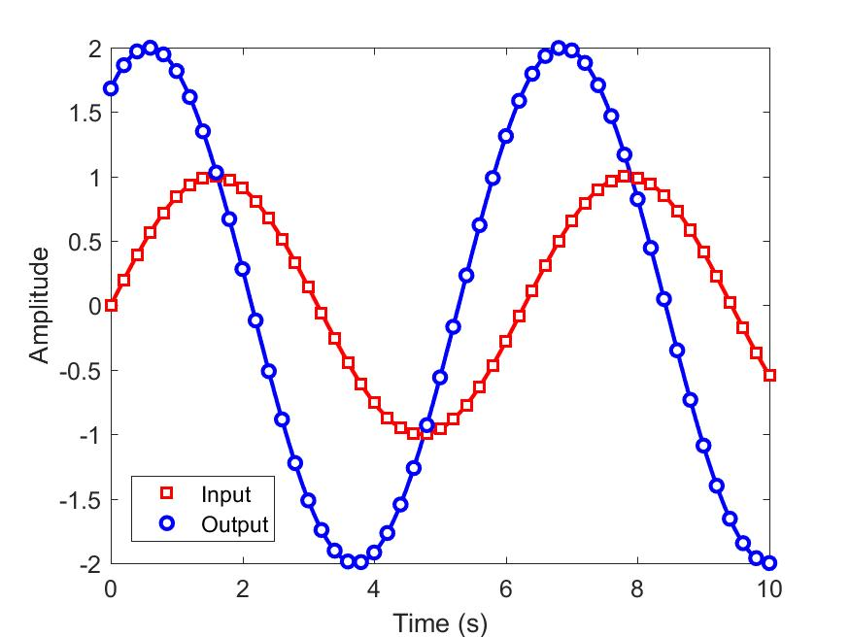

Figure 1 – Amplitude of the input and output signals. (Helvetica 9pt Bold Centered)

Try to place your figures “In line with text.” If this is not the default option in your MS Word, you can right-click your figure and verify under “Format Figure…”, under the tab “Layout” if the “Wrapping Style” indicates “In line with text,” as seen in Fig. 2.



Figure 2 – Screenshot of MS Word Format Picture window. (Helvetica 9pt Bold Centered)

Tables must be referred to either as “Tab. 1” in the middle of a phrase, or as “Table 1” at the beginning of a sentence. The tables themselves, as well as their titles, must be centered in the horizontal direction. Use the styles “Table Text” and “Table Title” to format the tables. Notice that they are automatically spaced from paragraphs. Units must be expressed in the S.I. (metric) system. Explanations, if any, must be given at the foot of the tables, not within the tables themselves. The style of table borders is left free. An example is given in Tab. 1. The table caption must precede the table, and the style used in Tab. 1 must be used, as was done for the figures.

Table 1 – Experimental results for flexural properties of CFRC-4HS and CFRC-TWILL composites. Span/depth ratio = 35:1. Average results of 7 specimens. (Helvetica 9pt Bold Centered)

|  |  |  |
| --- | --- | --- |
| Composite Properties | CFRC-TWILL | CFRC-4HS |
| Flexural Strength (MPa) | 209 ± 10 | 180 ± 15 |
| Flexural Modulus (GPa) | 57.0 ± 2.8 | 18.0 ± 1.3 |
| Mid-span deflection at the failure stress (mm) | 2.15 ± 1.90 | 6.40 ± 0.25 |

# Generation of the PDF file (Heading 1, Helvetica 11pt bold all caps)

The file name must be that of your Paper ID. For example, MSL-2022-0001.pdf. One possible source of problems with large files is the figures. In order to avoid this problem, favor EPS, GIF and JPEG figure formats.

For those using MS Word, the PDF file generation can be done either directly, if Adobe Distiller or the Adobe PDF Writer is available, or through a Postscript file, which will be converted to PDF at a later stage. In the second case, first you need to install a Postscript printer and use the option “Print to File” to generate a Postscript file. One way Postscript files can be converted to PDF is by using Ghostview (<http://www.cs.wisc.edu/~ghost/>). In order to avoid problems with fonts, it is recommended to use only the Times New Roman, Symbol, and Helvetica font faces in the entire document, including figures, tables, and captions. If you do not succeed in generating a proper digital version of your PDF file, please do not hesitate to contact the organizing committee.

# Acknowledgments (Heading 1, Helvetica 11pt bold all caps)

This optional section must be placed before the list of references.

# References (Heading 1, Helvetica 11pt bold all caps)

The list of references must be introduced as a new section, located at the end of the paper. The first line of each reference must be left-aligned. All the other lines must be spaced by 1 cm from the left margin. All references included in the reference list must have been mentioned in the preceding text. References must be listed in alphabetical order, according to the last name of the first author, as in the following examples:

ABCM, 2004, “Journal of the Brazilian Society of Engineering and Mechanical Sciences”, http://www.abcm.org.br/journal/index.shtml.

Bordalo, S.N., Ferziger, J.H. and Kline, S.J., 1989, “The Development of Zonal Models for Turbulence”, Proceedings of the 10th Brazilian Congress of Mechanical Engineering, Vol.1, Rio de Janeiro, Brazil, pp. 41-44.

Coimbra, A.L., 1978, “Lessons of Continuum Mechanics”, Ed. Edgard Blücher, S.Paulo, Brazil, 428 p.

Clark, J.A.,1986, Private Communication, University of Michigan, Ann Harbor.

Soviero, P.A.O. and Lavagna, L.G.M., 1997, “A Numerical Model for Thin Airfoils in Unsteady Motion”, RBCM- J. of the Brazilian Soc. Mechanical Sciences, Vol.19, No. 3, pp. 332-340.

Sparrow, E.M., 1980, “Forced Convection Heat Transfer in a Duct Having Spanwise-Periodic Rectangular Protuberances”, Numerical Heat Transfer, Vol.3, pp. 149-167.

# Responsibility notice (Heading 1, Helvetica 11pt bold all caps)

The author(s) is (are) the only party(ies) responsible for the printed material included in this paper.