EPTT-2022-XXXX (XXXX is the manuscript number, times new roman, centered, bold, size 14 )
Instructions for Formatting the Papers of EPTT 2024
(TIMES NEW ROMAN, BOLD, SIZE 14)
(single blank line size 14)
First Author’s Name (Times New Roman, Bold, size 10)
Second Author’s Name (Times New Roman, Bold, size 10)
Institution and address (Times New Roman, size 9)
e-mails (Times New Roman, size 9)
(single space line, size 10)
Third Author’s Name (Times New Roman, Bold, size 10)
Institution and address (Times New Roman, size 9)
e-mail(Times New Roman, size 9)
(single space line, size 10)
Same format for other authors, if any
(single space line, size 10)
Abstract. The purpose of these instructions is to serve as a guide for formatting papers to be published in the Proceedings of the 14th Spring School on Transition and Turbulence, EPTT 2024. The abstract section should describe the objectives, the methodology and the main conclusions of the paper in about 200 words. It should not contain equations or references to bibliography. (Times New Roman, italic, size 10)
(single space line, size 10)
Keywords: keyword 1, keyword 2, keyword 3 … (up to 5 keywords) (Times New Roman, italic, size 10)
(single space line, size 10)
- Introduction (Times New Roman, bold, size 10)
(single space line, size 10)
The proceedings of the EPTT 2024 will be published in Adobe™ PDF format. The extended abstracts and final papers must be formatted strictly according to these instructions. The present file can be used as a template for Microsoft Word™ users. This document should be used as a formatting guide to users of other text processing software.
The draft paper should have maximum of 10 pages, including the following sections: introduction, methodology, results and discussions and conclusions/additions to the final paper (when applicable).
(single space line, size 10)
- Text format
(single space line, size 10)
The manuscripts should be written in English, typed in A4 size pages, using font Times New Roman, size 10, except for the title, authors affiliation, abstract and keywords, for which particular formatting instructions are indicated above. Single space between lines is to be used throughout the text.
The text block that contains the title, the authors’ names and affiliations, the abstract and the keywords must be indented 0.1 cm from the left margin and marked by a leftmost black line border of width 2 ¼ pt.
The first page must have a top margin of 3 cm and all the other margins (left, right and bottom) must have 2 cm. All the other pages must be set with all margins equal to 2 cm.
PAGES SHOULD NOT BE NUMBERED
The body of the text must be justified. The first line of each paragraph must be indented by 0.5 cm. Sufficient information must be provided directly in the text, or by reference to widely available published work. Footnotes should be avoided.
All the symbols and notation must be defined in the text. Physical quantities must be expressed in the SI (metric) units. In order to avoid units braking in the next line use Ctrl+Shift+space between the numerical value and the unit. Mathematical symbols appearing in the text must be typed in italic style.
Bibliographic references should be cited in the text by giving the last name of the author(s) and the year of publication, according to the following examples: “Recent work (de Oliveira and Melo, 2013)” or “Recently, McConnell and Varoto (2008)”. In the case of three or more authors, the form “Rodriguez, et al., 2006” should be used. Two or more references having the same authors and publication year must be distinguished by appending “a”, “b”, etc., to the year of publication. For example: “Recent work (Trindade and Benjeddou, 2011a)”.
Acceptable references include journal articles (Trindade and Benjeddou, 2011a), numbered papers, dissertations, theses (Lee, 2003), published conference proceedings (de Oliveira and Melo, 2013; Rodriguez et al., 2006; Trindade and Benjeddou, 2011b), preprints from conferences, books (McConnell and Varoto, 2008), submitted articles (if the journal is identified) and private communications (Clark, 1986). Internet sites can also be cited as references (ABCM, 2004; MLA, 2004).
References should be listed at the end of the paper according to instructions provided in Section 4.
(single space line, size 10)
- Section titles and subtitles
(single space line, size 10)
The section headers and sub headers must be aligned on the left, typed with Times New Roman, size 10, bold style font. They must be numbered using Arabic numerals separated by points. The current MS Word template provides automatic numbering. No more than 3 sublevels should be used. One single line size 10 must be included above and below each section title/subtitle (use the Section Body style).
(single space line, size 10)
- Mathematical equations
(single space line, size 10)
The mathematical equations must be indented by 0.5 cm from the left margin. They must be typed using Times New Roman, italic, size 10 pt. font. Arabic numerals must be used as equation numbers, enclosed between parentheses, right-aligned, as shown in the examples below. Equations should be referred to either as “Eq. (1)” in the middle of a phrase or as “Equation (1)” in the beginning of a sentence. Matrix and vector quantities can be indicated either by brackets and braces, as in Eq. (1), or in bold style, as in Eq. (2). Symbols used in the equations must be defined immediately before or after their first appearance.
One blank line must be included above and below each equation.
(single space line, size 10)
$c_{nf}=\frac{\left(1-ϕ_{v}\right)\left(ρ_{fb}c_{fb}\right)+ϕ_{v}ρ_{np}c_{np}}{ϕ_{v}ρ_{np}+\left(1-ϕ_{v}\right)ρ_{fb}}$ (1)
(single space line, size 10)
$μ_{nf}=\left(\frac{1}{1-34,87 {({d_{p}}/{d_{f}})}^{-0,3}ϕ^{1,03})}\right) μ_{fb}$ (2)
(single space line, size 10)
- Figures and tables
(single space line, size 10)
Figures and tables should be placed in the text as close as possible to the point where they are first mentioned and must be numbered consecutively in Arabic numerals. Figures must be referred to either as “Fig. 1” in the middle of a phrase or as “Figure 1” in the beginning of a sentence. The figures themselves as well as their captions must be centered in the breadth-wise direction. The captions of the figures should not be longer than 3 lines, centered and use Times New Roman size 10.
The caption for the data symbols as well as the labels for each curve should be included into the figure. Lettering should be large enough for ease reading. All units must be expressed in the S.I. (metric) system.
One blank line must be left before and after each figure.
(single space line, size 10)
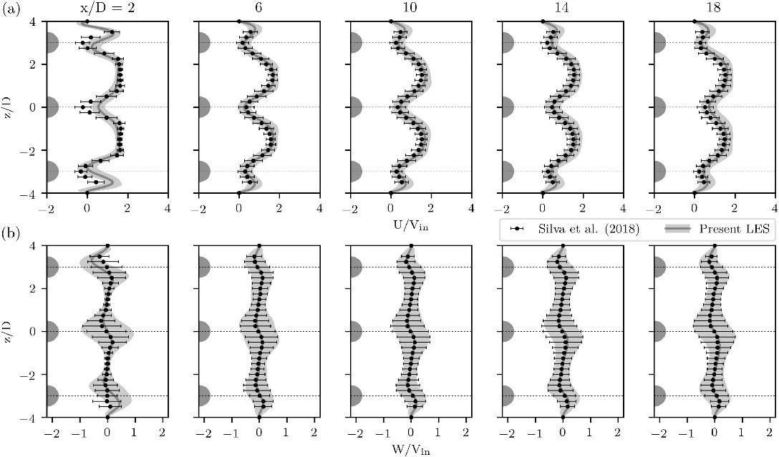
(single space line, size 10)
Figure 1. Normalized time-averaged velocity distribution. (a) Streamwise velocity and (b) Crosswise velocity.

(single space line, size 10)
One blank line must be left before and after each table.
The style of the table borders is left free. An example is given in Tab. 1.
(single space line, size 10)
Table 1. Experimental results for flexural properties of CFRC-4HS and CFRC-TWILL composites.
Span/depth ratio = 35:1. Average results of 7 specimens.
(single space line, size 10)
Composite Properties | CFRC-TWILL | CFRC-4HS
Flexural Strength (MPa)⁽¹⁾ | 209 ± 10 | 180 ± 15
Flexural Modulus (GPa)⁽¹⁾ | 57.0 ± 2.8 | 18.0 ± 1.3
Mid-span deflection at the failure stress (mm) | 2.15 ± 1.90 | 6.40 ± 0.25
⁽¹⁾ measured at 25°C
(single space line, size 10)
- Acknowledgements
(single space line, size 10)
This optional section must be placed before the list of references.
(single space line, size 10)
- References
(single space line, size 10)
The list of references must be introduced as a new section, located at the end of the paper. The first line of each reference must be aligned at left. All the other lines must be indented by 0.5 cm from the left margin. All references included in the reference list must have been mentioned in the text.
References must be listed in alphabetical order, according to the last name of the first author. See the following examples:

ABCM, 2004. “Journal of the Brazilian Society of Engineering and Mechanical Sciences”. 1 Feb. 2007 <http://www.abcm.org.br/journal/index.shtml>.
Clark, J.A., 1986. Private Communication. University of Michigan, Ann Harbor.
de Oliveira, L.P.R. and Melo, F.X., 2013. “Tpa as a tool for the desing of active noise control”. In Proceedings of the International Symposium on Dynamic Problems of Mechanics - DINAME2013. Buzios, Brazil.
Lee, Y.B., 2003. Studies on the growth of the frost layer based on heat and mass transfer through porous media. Ph.D. thesis, Seoul National University, Seoul.
McConnell, K.G. and Varoto, P.S., 2008. Vibration Testing: Theory and Practice. John Wiley & Sons, New Jersey, 2nd edition.
MLA, 2004. “How do I document sources from the web in my works-cited list?” Modern Language Association. 22 Feb. 2007 <http://www.mla.org>.
Rodriguez, O.M.H., Mudde, R.F. and Oliemans, R.V.A., 2006. “Stability analysis of slightly-inclined stratified oil-water flow and intermediate wave theory”. In Proceedings of the 11th Brazilian Congress of Thermal Sciences and Engineering - ENCIT2006. Curitiba, Brazil.
Trindade, M.A. and Benjeddou, A., 2011a. “Finite element homogenization technique for the characterization of d15 shear piezoelectric macro-fibre composites”. Smart Materials and Structures, Vol. 20, p. 075012.
Trindade, M.A. and Benjeddou, A., 2011b. “Evaluation of effective material properties of thickness-shear piezoelectric macro-fibre composites”. In Proceedings of the 21st International Congress of Mechanical Engineering -COBEM2011. Natal, Brazil.
(single space, size 10)
- Responsibility notice
(single space, size 10)
The following text, properly adapted to the number of authors, must be included in the last section of the paper:
The author(s) is (are) the only responsible for the printed material included in this paper.

